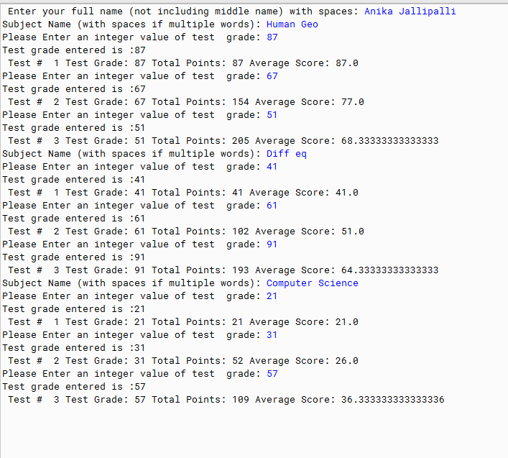

PMR: This was not easy. It took me almost 3 days to complete as well as the help of my dad. I am happy to understand this, but it is very tedious. Not my favorite.

/\*\*

\* The purpose of the program is to calculate the grade point

\* average of a student

\*

\* @author Anika Jallipalli

\* @version 09/15/2019

\*/

import java.util.Scanner; //imports Scanner methods

public class GradesV3

{

public static void main(String [ ] args)

{

//construct a Scanner object with one line

Scanner in = new Scanner(System.in);

//local variables

int numTests = 0; //counts number of tests

int testGrade = 0; //individual test grade

int totalPoints = 0; //total points for all tests

double average = 0.0; //average grade

//Students Name

System.out.print("Enter your full name (not including middle name) with spaces: ");

String word1 = in.next();

String word2 = in.next();

/\*

\* Scanner in;

\* in = new Scanner(System.in);

\* System.out.print("Please enter an integer value: ");

\* int intValue = in.nextInt();

\*/

//Scanner in;

System.out.print("");

System.out.print("Subject Name (with spaces if multiple words): ");

String word3 = in.next();

String word4 = in.next();

System.out.print("");

numTests = 0; //counts number of tests

testGrade = 0; //individual test grade

totalPoints = 0; //total points for all tests

average = 0.0; //average grade

System.out.print("Please Enter an integer value of test grade: ");

int intValue0 = in.nextInt();

System.out.print("");

System.out.print("Test grade entered is :"+ intValue0);

testGrade = intValue0;

numTests++;

totalPoints+= testGrade;

average= (double)totalPoints / numTests;

System.out.println("");

System.out.print(" Test # " + numTests);

System.out.print(" Test Grade: " + testGrade);

System.out.print(" Total Points: " + totalPoints);

System.out.println(" Average Score: " + average);

System.out.print("");

System.out.print("Please Enter an integer value of test grade: ");

int intValue1 = in.nextInt();

System.out.print("");

System.out.print("");

System.out.print("Test grade entered is :"+ intValue1);

System.out.print("");

testGrade = intValue1;

numTests++;

totalPoints+= testGrade;

average= (double)totalPoints / numTests;

System.out.println("");

System.out.print(" Test # " + numTests);

System.out.print(" Test Grade: " + testGrade);

System.out.print(" Total Points: " + totalPoints);

System.out.println(" Average Score: " + average);

System.out.print("");

System.out.print("Please Enter an integer value of test grade: ");

int intValue2 = in.nextInt();

System.out.print("");

System.out.print("");

System.out.print("Test grade entered is :"+ intValue2);

System.out.print("");

testGrade = intValue2;

numTests++;

totalPoints+= testGrade;

average= (double)totalPoints / numTests;

System.out.println("");

System.out.print(" Test # " + numTests);

System.out.print(" Test Grade: " + testGrade);

System.out.print(" Total Points: " + totalPoints);

System.out.println(" Average Score: " + average);

System.out.print("");

System.out.print("");

System.out.print("Subject Name (with spaces if multiple words): ");

String word5 = in.next();

String word6 = in.next();

System.out.print("");

System.out.print("");

numTests = 0; //counts number of tests

testGrade = 0; //individual test grade

totalPoints = 0; //total points for all tests

average = 0.0; //average grade

System.out.print("Please Enter an integer value of test grade: ");

int intValue3 = in.nextInt();

System.out.print("");

System.out.print("Test grade entered is :"+ intValue3);

testGrade = intValue3;

numTests++;

totalPoints+= testGrade;

average= (double)totalPoints / numTests;

System.out.println("");

System.out.print(" Test # " + numTests);

System.out.print(" Test Grade: " + testGrade);

System.out.print(" Total Points: " + totalPoints);

System.out.println(" Average Score: " + average);

System.out.print("");

System.out.print("Please Enter an integer value of test grade: ");

int intValue4 = in.nextInt();

System.out.print("");

System.out.print("");

System.out.print("Test grade entered is :"+ intValue4);

System.out.print("");

testGrade = intValue4;

numTests++;

totalPoints+= testGrade;

average= (double)totalPoints / numTests;

System.out.println("");

System.out.print(" Test # " + numTests);

System.out.print(" Test Grade: " + testGrade);

System.out.print(" Total Points: " + totalPoints);

System.out.println(" Average Score: " + average);

System.out.print("");

System.out.print("Please Enter an integer value of test grade: ");

System.out.print("");

int intValue5 = in.nextInt();

System.out.print("");

System.out.print("Test grade entered is :"+ intValue5);

System.out.print("");

testGrade = intValue5;

numTests++;

totalPoints+= testGrade;

average= (double)totalPoints / numTests;

System.out.println("");

System.out.print(" Test # " + numTests);

System.out.print(" Test Grade: " + testGrade);

System.out.print(" Total Points: " + totalPoints);

System.out.println(" Average Score: " + average);

System.out.print("");

System.out.print("Subject Name (with spaces if multiple words): ");

System.out.print("");

String word7 = in.next();

String word9 = in.next();

System.out.print("");

numTests = 0; //counts number of tests

testGrade = 0; //individual test grade

totalPoints = 0; //total points for all tests

average = 0.0; //average grade

System.out.print("Please Enter an integer value of test grade: ");

System.out.print("");

int intValue6 = in.nextInt();

System.out.print("");

System.out.print("Test grade entered is :"+ intValue6);

System.out.print("");

testGrade = intValue6;

numTests++;

totalPoints+= testGrade;

average= (double)totalPoints / numTests;

System.out.println("");

System.out.print(" Test # " + numTests);

System.out.print(" Test Grade: " + testGrade);

System.out.print(" Total Points: " + totalPoints);

System.out.println(" Average Score: " + average);

System.out.print("");

System.out.print("Please Enter an integer value of test grade: ");

System.out.print("");

int intValue7 = in.nextInt();

System.out.print("");

System.out.print("Test grade entered is :"+ intValue7);

System.out.print("");

testGrade = intValue7;

numTests++;

totalPoints+= testGrade;

average= (double)totalPoints / numTests;

System.out.println("");

System.out.print(" Test # " + numTests);

System.out.print(" Test Grade: " + testGrade);

System.out.print(" Total Points: " + totalPoints);

System.out.println(" Average Score: " + average);

System.out.print("");

System.out.print("Please Enter an integer value of test grade: ");

System.out.print("");

int intValue8 = in.nextInt();

System.out.print("");

System.out.print("Test grade entered is :"+ intValue8);

System.out.print("");

testGrade = intValue8;

numTests++;

totalPoints+= testGrade;

average= (double)totalPoints / numTests;

System.out.println("");

System.out.print(" Test # " + numTests);

System.out.print(" Test Grade: " + testGrade);

System.out.print(" Total Points: " + totalPoints);

System.out.println(" Average Score: " + average);

}//end of main method

}//end of class